EQUATOR Network Lightning Workshop
Planning your publication

0. List authors and order

1. Define your message
Background
The problem or evidence gap
Methods
What you did to solve the problem
Results
What you found
Conclusions
What it means and why it matters

2. Decide the audiences and their next steps
- Healthcare professionals: all of them, nurses, a clinical speciality
- Other researchers: Laboratory, preclinical, reviewers
- Government and special interest groups
- Patients
- General public
3. Choose a medium
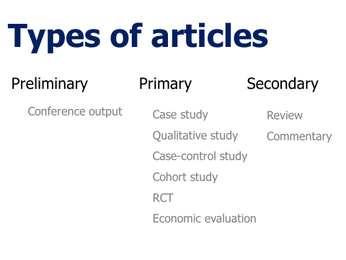
- Academic journal
- Popular press
- Social media
- Guidelines
- Patient information

4. Write your acknowledgements

5. Choose your target journal
- A real journal (www.thinkchecksubmit.org)
- Clinical/academic specialty
- Author career requirements
- Funder/institute requirements

6. Get ready to write
- Instructions for authors
- Reporting guidelines

- Revisit author list
- Assign co-authors writing tasks
- Get co-author approval of the plan
- Identify missing information
- Assign co-authors information-gathering tasks

